Aula 1)

<https://reactnative.dev/docs/environment-setup>

<https://reactnative.dev/docs/set-up-your-environment>

https://docs.expo.dev/get-started/create-a-project/  
<https://docs.expo.dev/get-started/set-up-your-environment/>

npx create-expo-app@latest  
npx expo start

Aula 2)  
TypeScript (javascript tunado)

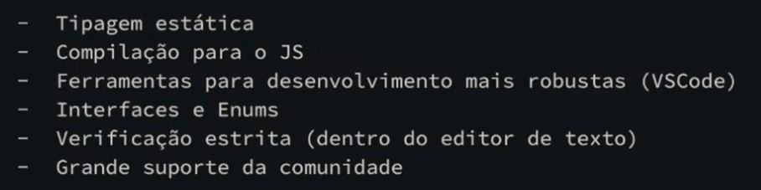

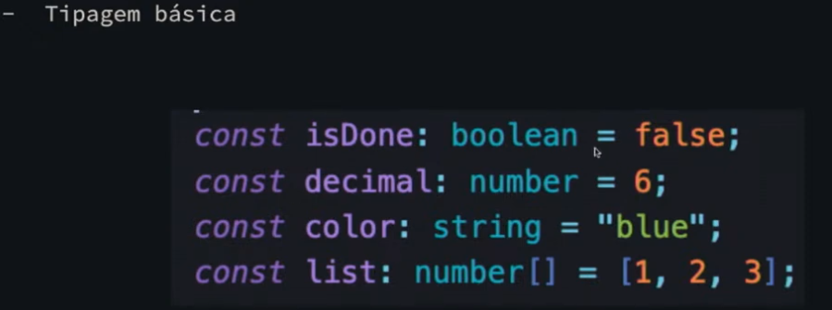

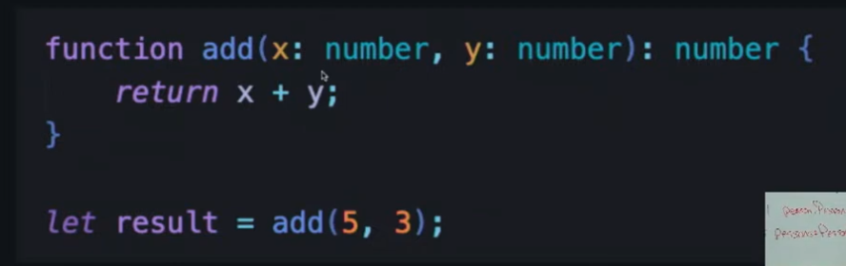

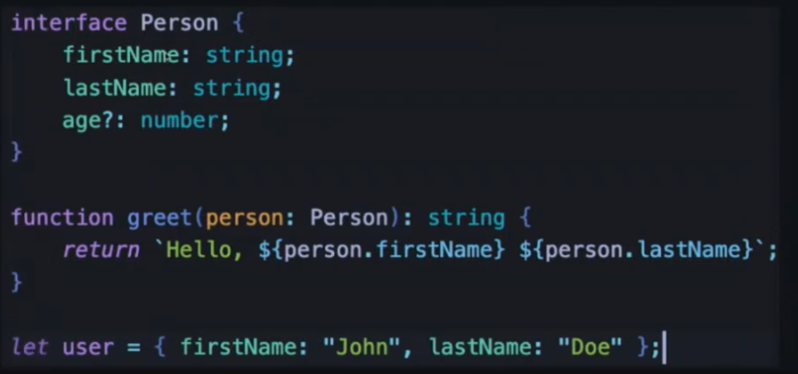

Interface Person = type Person

